NOTICE OF MINOR VARIANCE APPLICATION AND PUBLIC HEARING

DATE: THURSDAY, FEBRUARY 16, 2023 TIME: 9:30 A.M.
PLACE: Held Virtually via Zoom Platform, See Below for Details

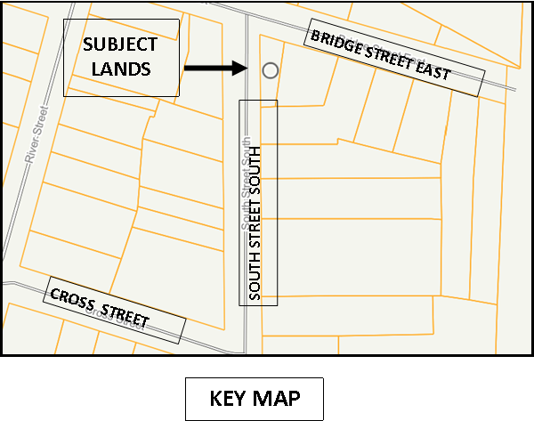
Under Section 45 of the Planning Act, R.S.O. 1990, cp. 13, as amended, COMMITTEE OF ADJUSTMENT OF THE CITY OF THOROLD HAS APPOINTED February 16, 2023 at 9:30 a.m. to meet for the purpose of a Public Hearing to consider an application for Minor Variance in the matter of:

Application: D13-01-2023

Roll No.: 2731 000 029 14600 0000

Subject Lands: 65 Bridge Street East
Plan M10 Lot 34
Thorold, ON

Date of Mailing: January 27, 2022

PURPOSE AND EFFECT OF THE PROPOSED MINOR VARIANCE:

The subject lands are designated Urban Living Area, along with Special Policy A-4 Port Robinson East Special Policy in the City of Thorold Official Plan and are zoned Residential First Density R1C in accordance with Zoning Bylaw 2140(97). The applicant is seeking a minor variance to construct a single detached dwelling with an accessory dwelling. In order to facilitate the development, as per Zoning Bylaw 2140(97), the following variances, for the change of use and exterior side yard setback reduction, from the R1C zone provisions are being requested:

- Provision 9.2(f) – To reduce the Exterior Side Yard Setback from 4.5 metres to 2.8 metres.

This application was deferred from the January hearing and the application has been amended. The application is no longer seeking a variance at this time to permit a second dwelling unit within the proposed single detached dwelling.

PUBLIC HEARING - You are entitled to be part of this public hearing to express your views about this application. If you are aware of any person interested in or affected by this application who has not received a copy of this notice you are asked to inform that person of this hearing.

Comments for or against this application may be forwarded, by telephone, mail or email (see below) to the Secretary-Treasurer. All submitted comments become part of a public record and will be circulated to the Committee of Adjustment, City staff, the owner/agent for application, members of the public who request the application comments and the Local Planning Appeal Tribunal if the application decision is appealed.

FAILURE TO PARTICIPATE – If you do not participate in the hearing, it may proceed in your absence and you will not be entitled to any further notice in the proceedings. If you wish to participate in this process, please see the note below for details.

ADDITIONAL INFORMATION regarding this application is available to the public by contacting Planning & Development Services Department through telephone, extension 259 or email at Angela.Nesbitt@thorold.ca.

NOTICE OF DECISION - Requests for copies of the decision of the Committee of Adjustment or notice of adjournment of hearings, if any, must be provided prior to the hearing and be addressed to:

Secretary Treasurer of the Committee of Adjustment
3540 Schmon Parkway, P.O. Box 1044. Thorold, ON L2V 4A7
905-227-6613 Angela.Nesbitt@thorold.ca

NOTE: DUE TO THE COVID-19 PANDEMIC, THIS PUBLIC MEETING WILL BE HELD BY VIRTUAL MEANS VIA ZOOM PLATFORM. IF YOU WISH TO BE PART OF THIS HEARING, PLEASE ADVISE THE SECRETARY TREASURER BY EMAIL AT Angela.Nesbitt@thorold.ca OR THE CLERK OF THE CITY OF THOROLD BY EMAIL AT clerk@thorold.ca BY 4:30 P.M. FEBRUARY 15, 2023.
